Phase II
Step 1: Install the Splunk Enterpriseb9.4.2 package on my Mac from the official website.
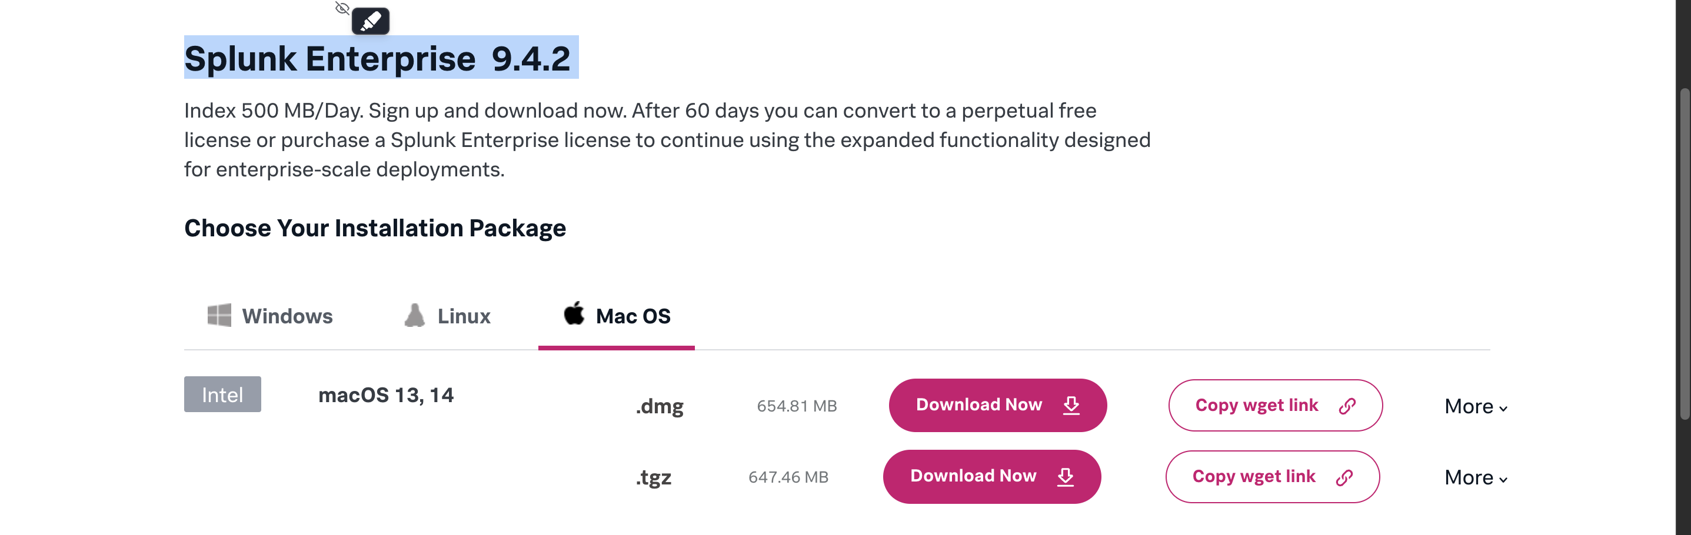
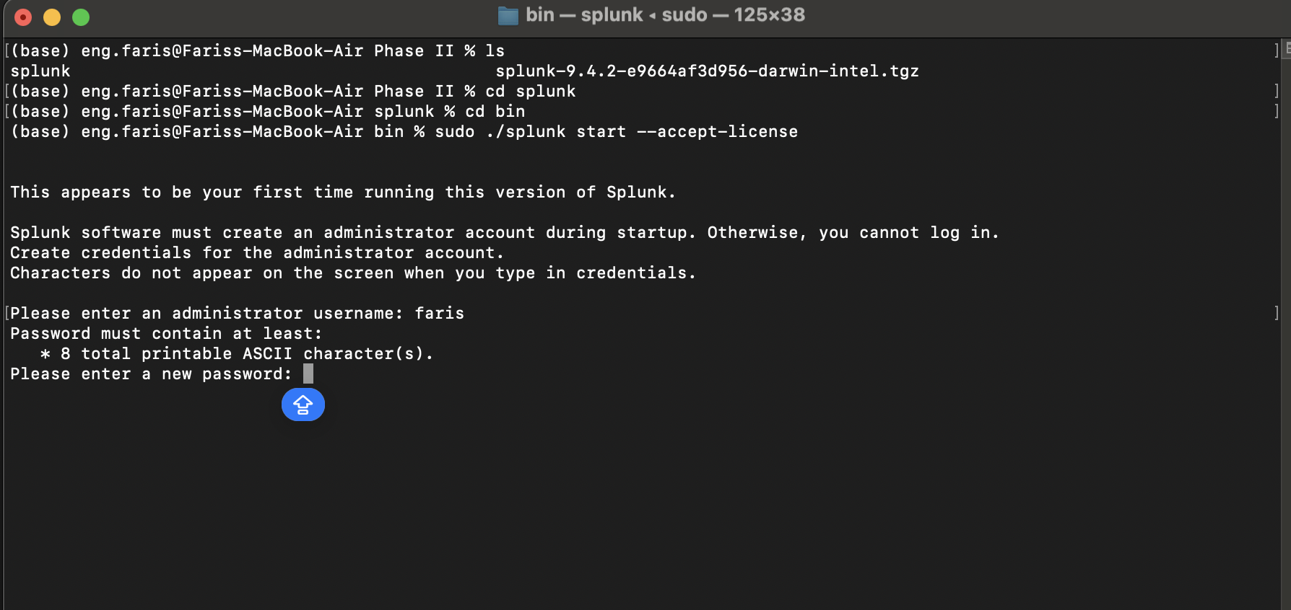
Step 2: Extract and Set Up
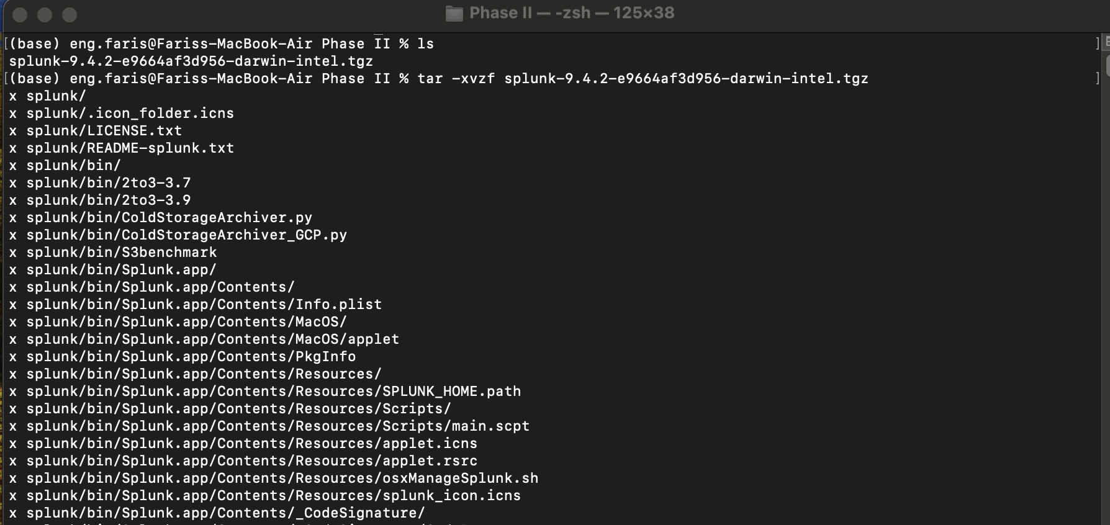

Step 3: Enable Receiving Data from Metasploitable3
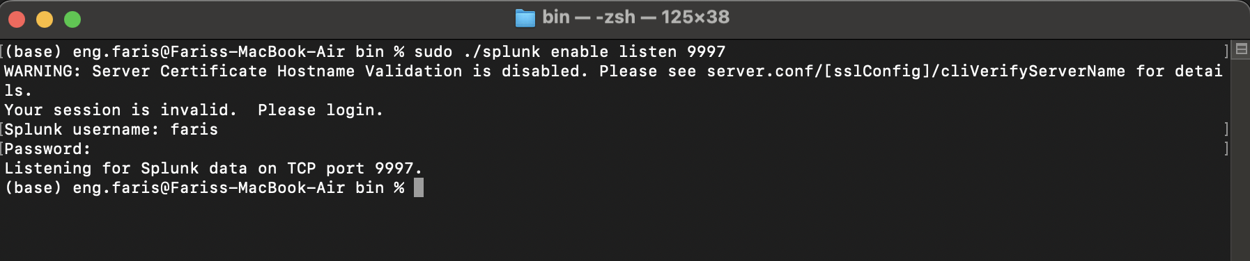

Step 4: Install & Set up the Splunk Universal Forwarder on Metasploitable3
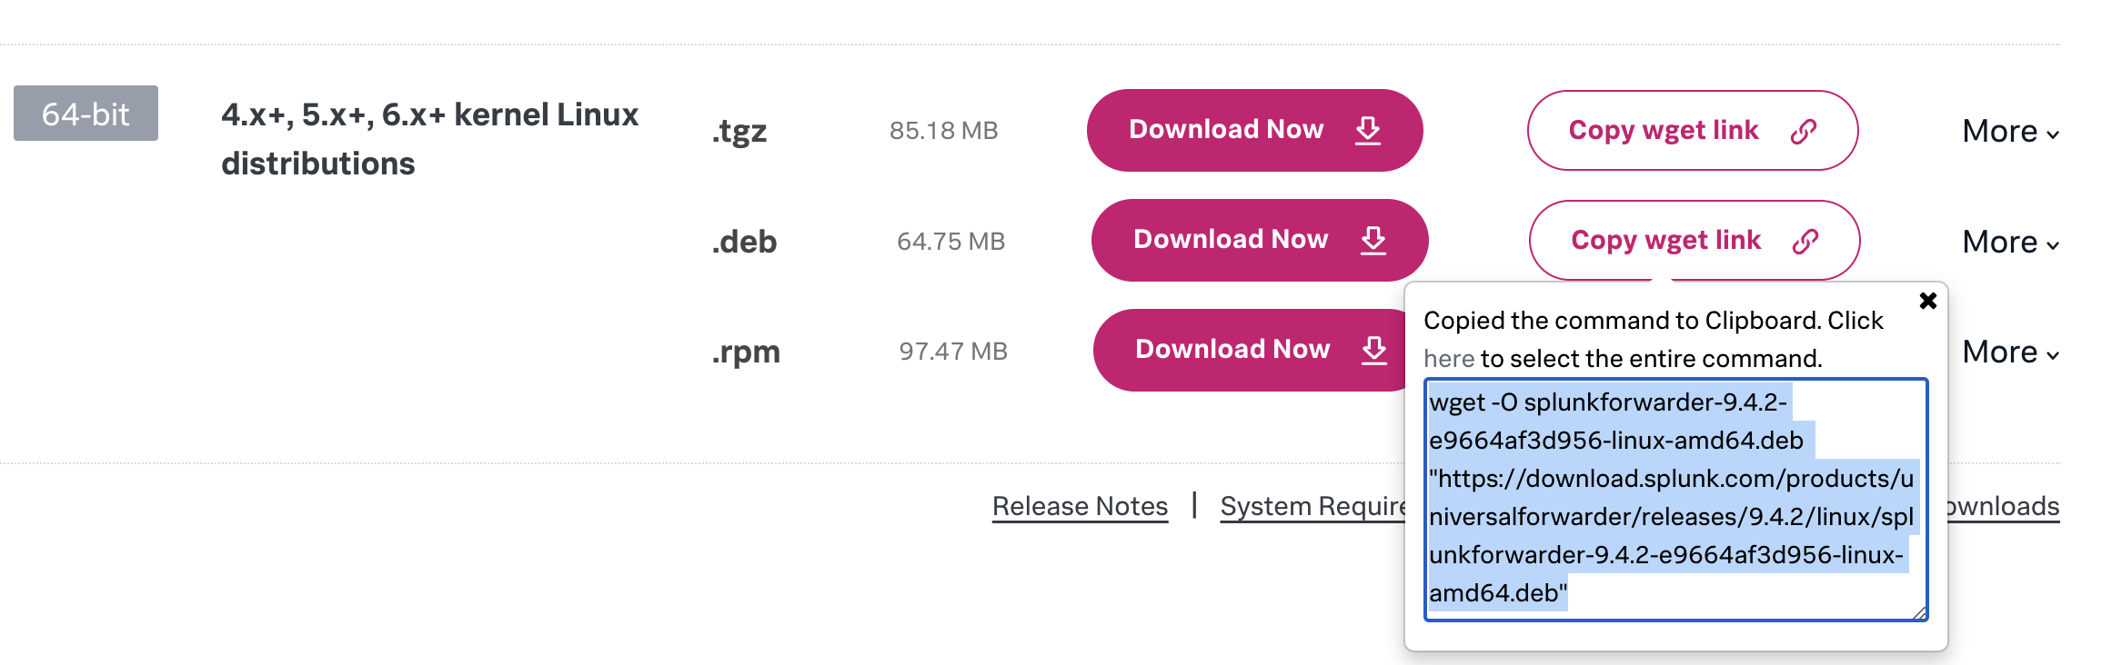
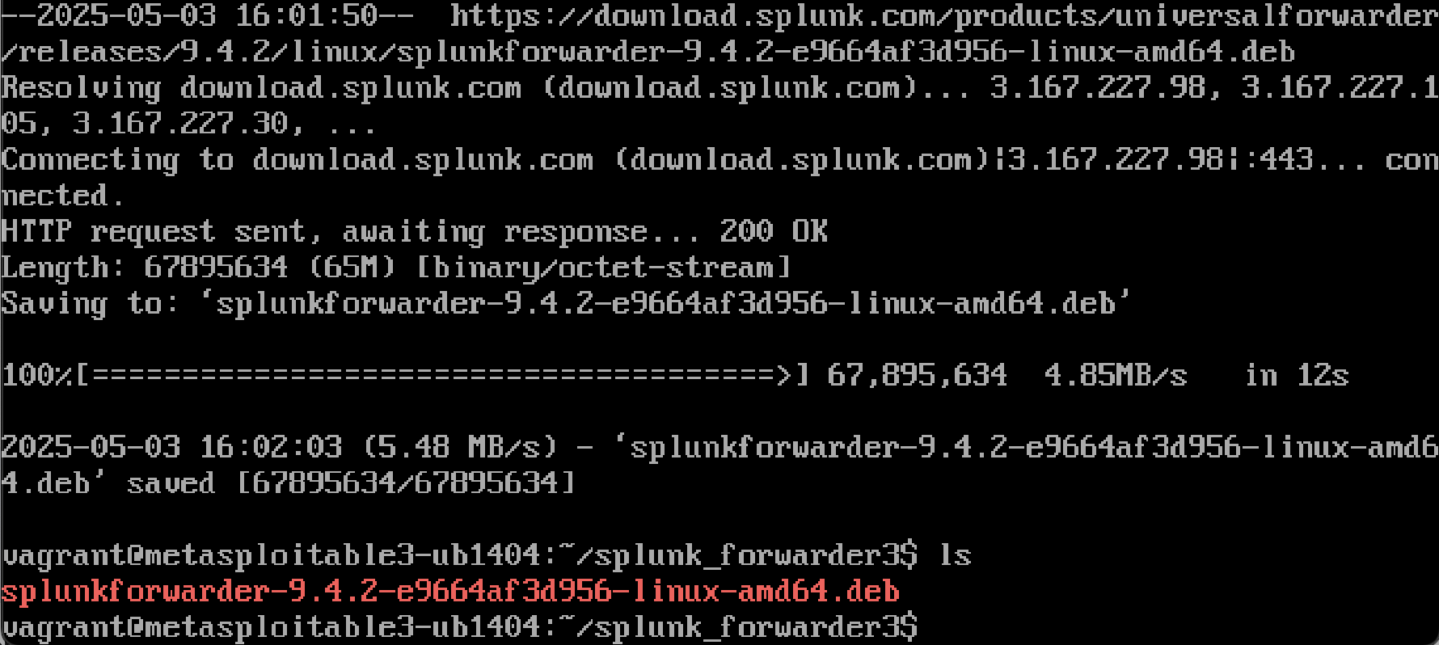

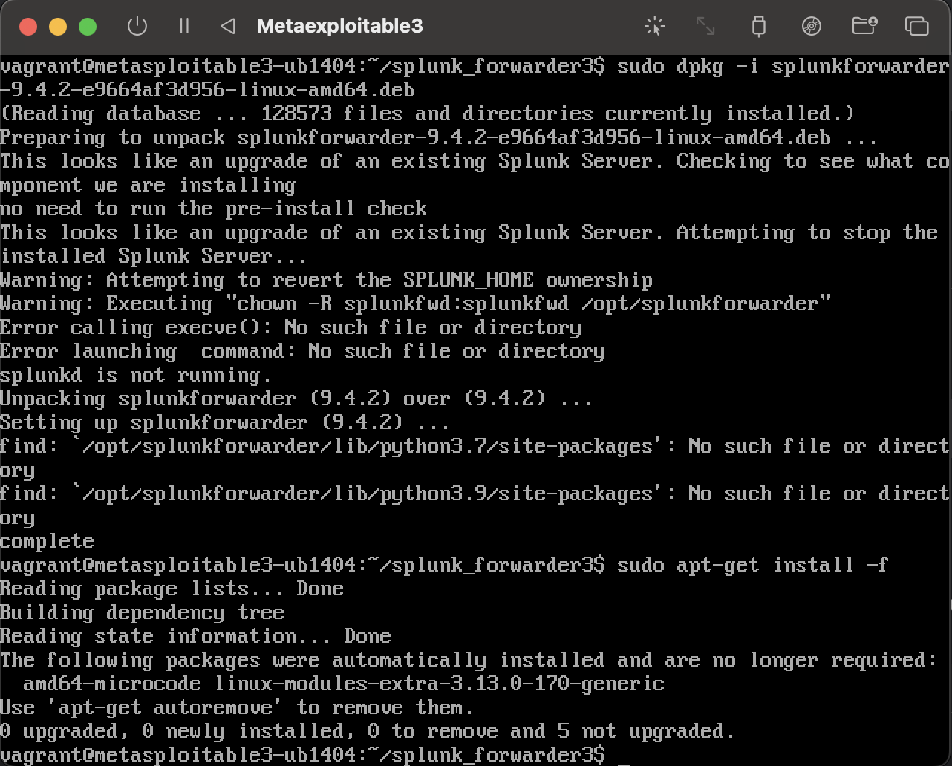
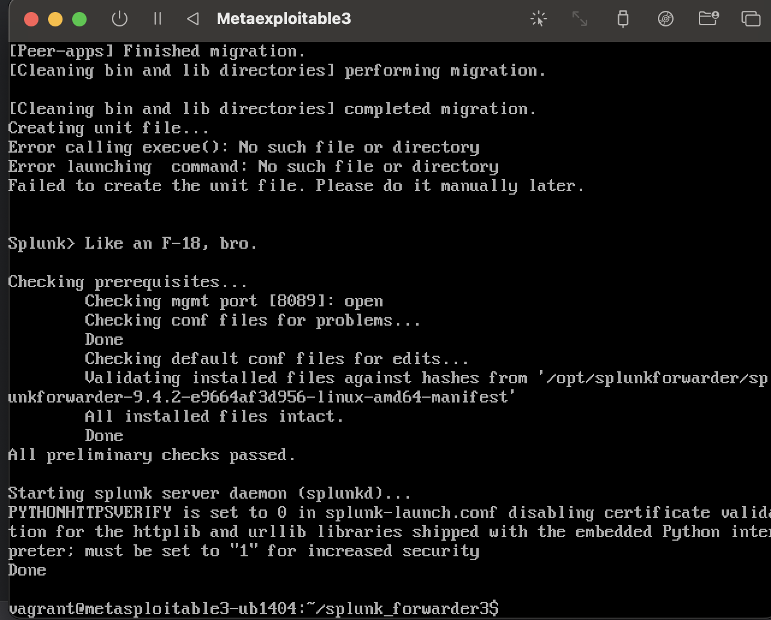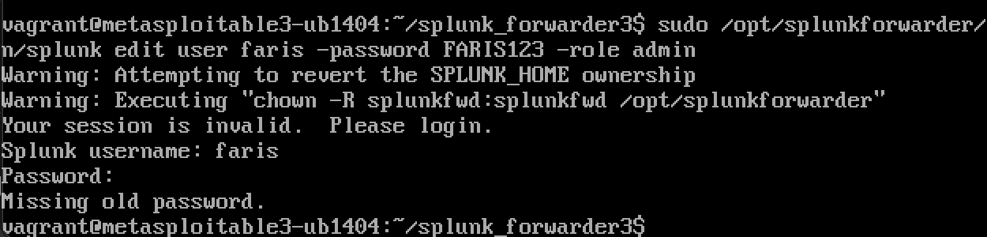

Step 5: Configure the Splunk Universal Forwarder to forward logs to my Splunk dashboard

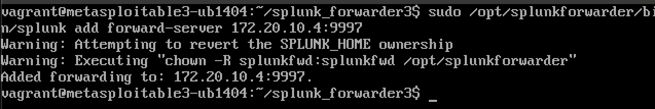
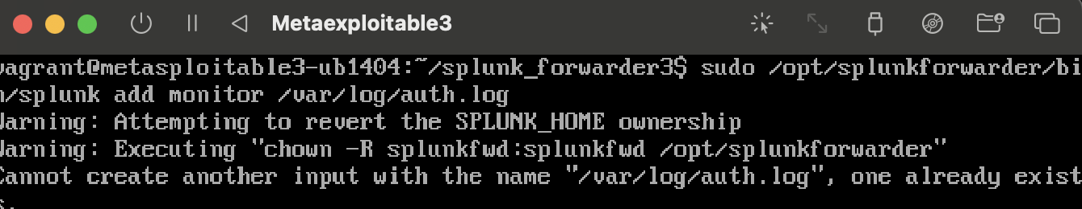
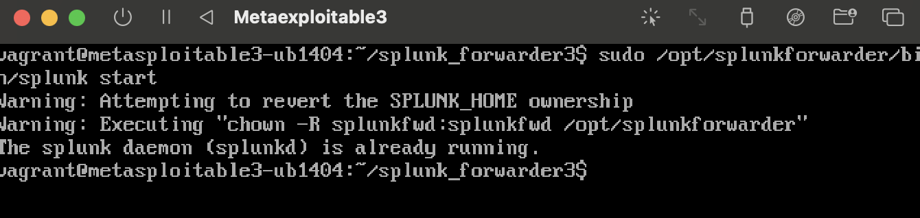
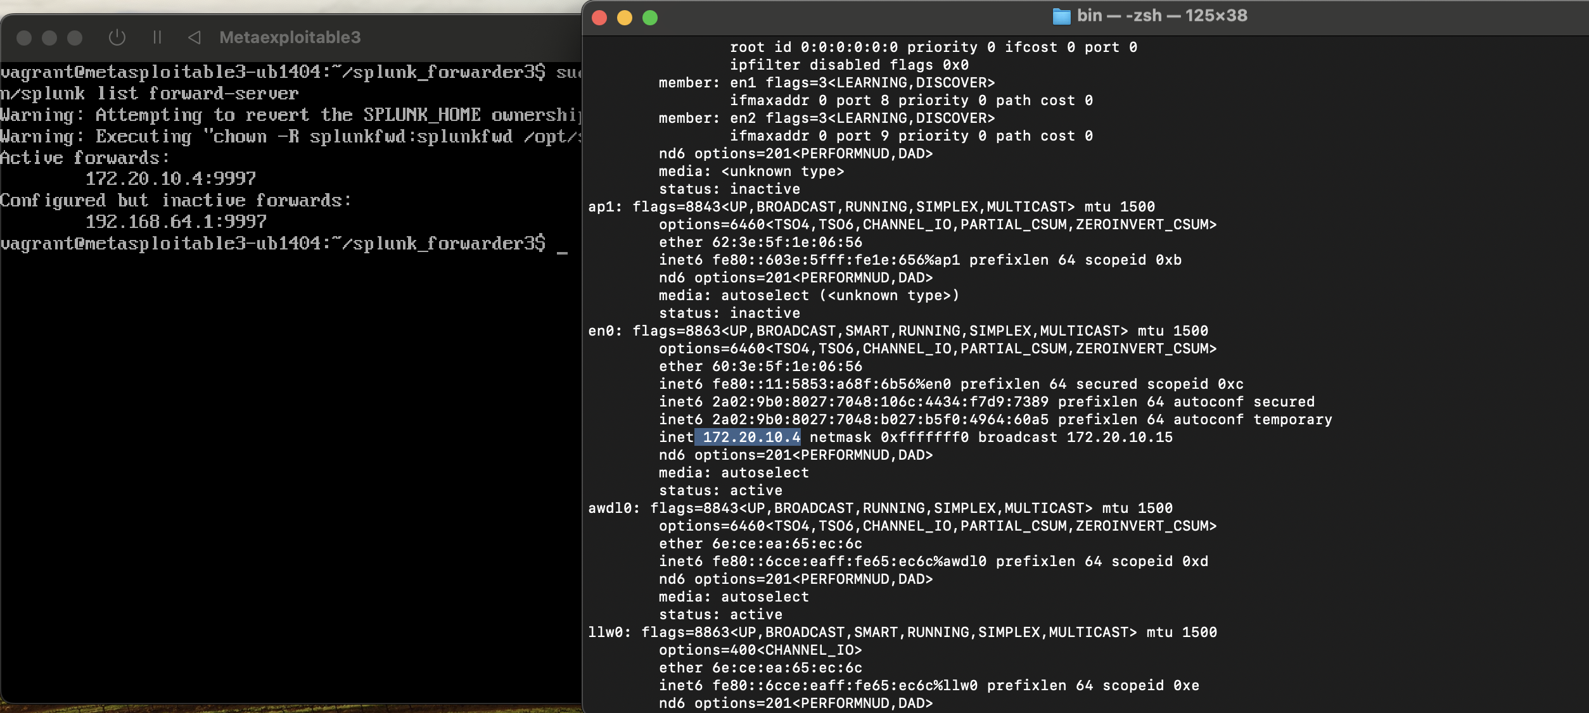

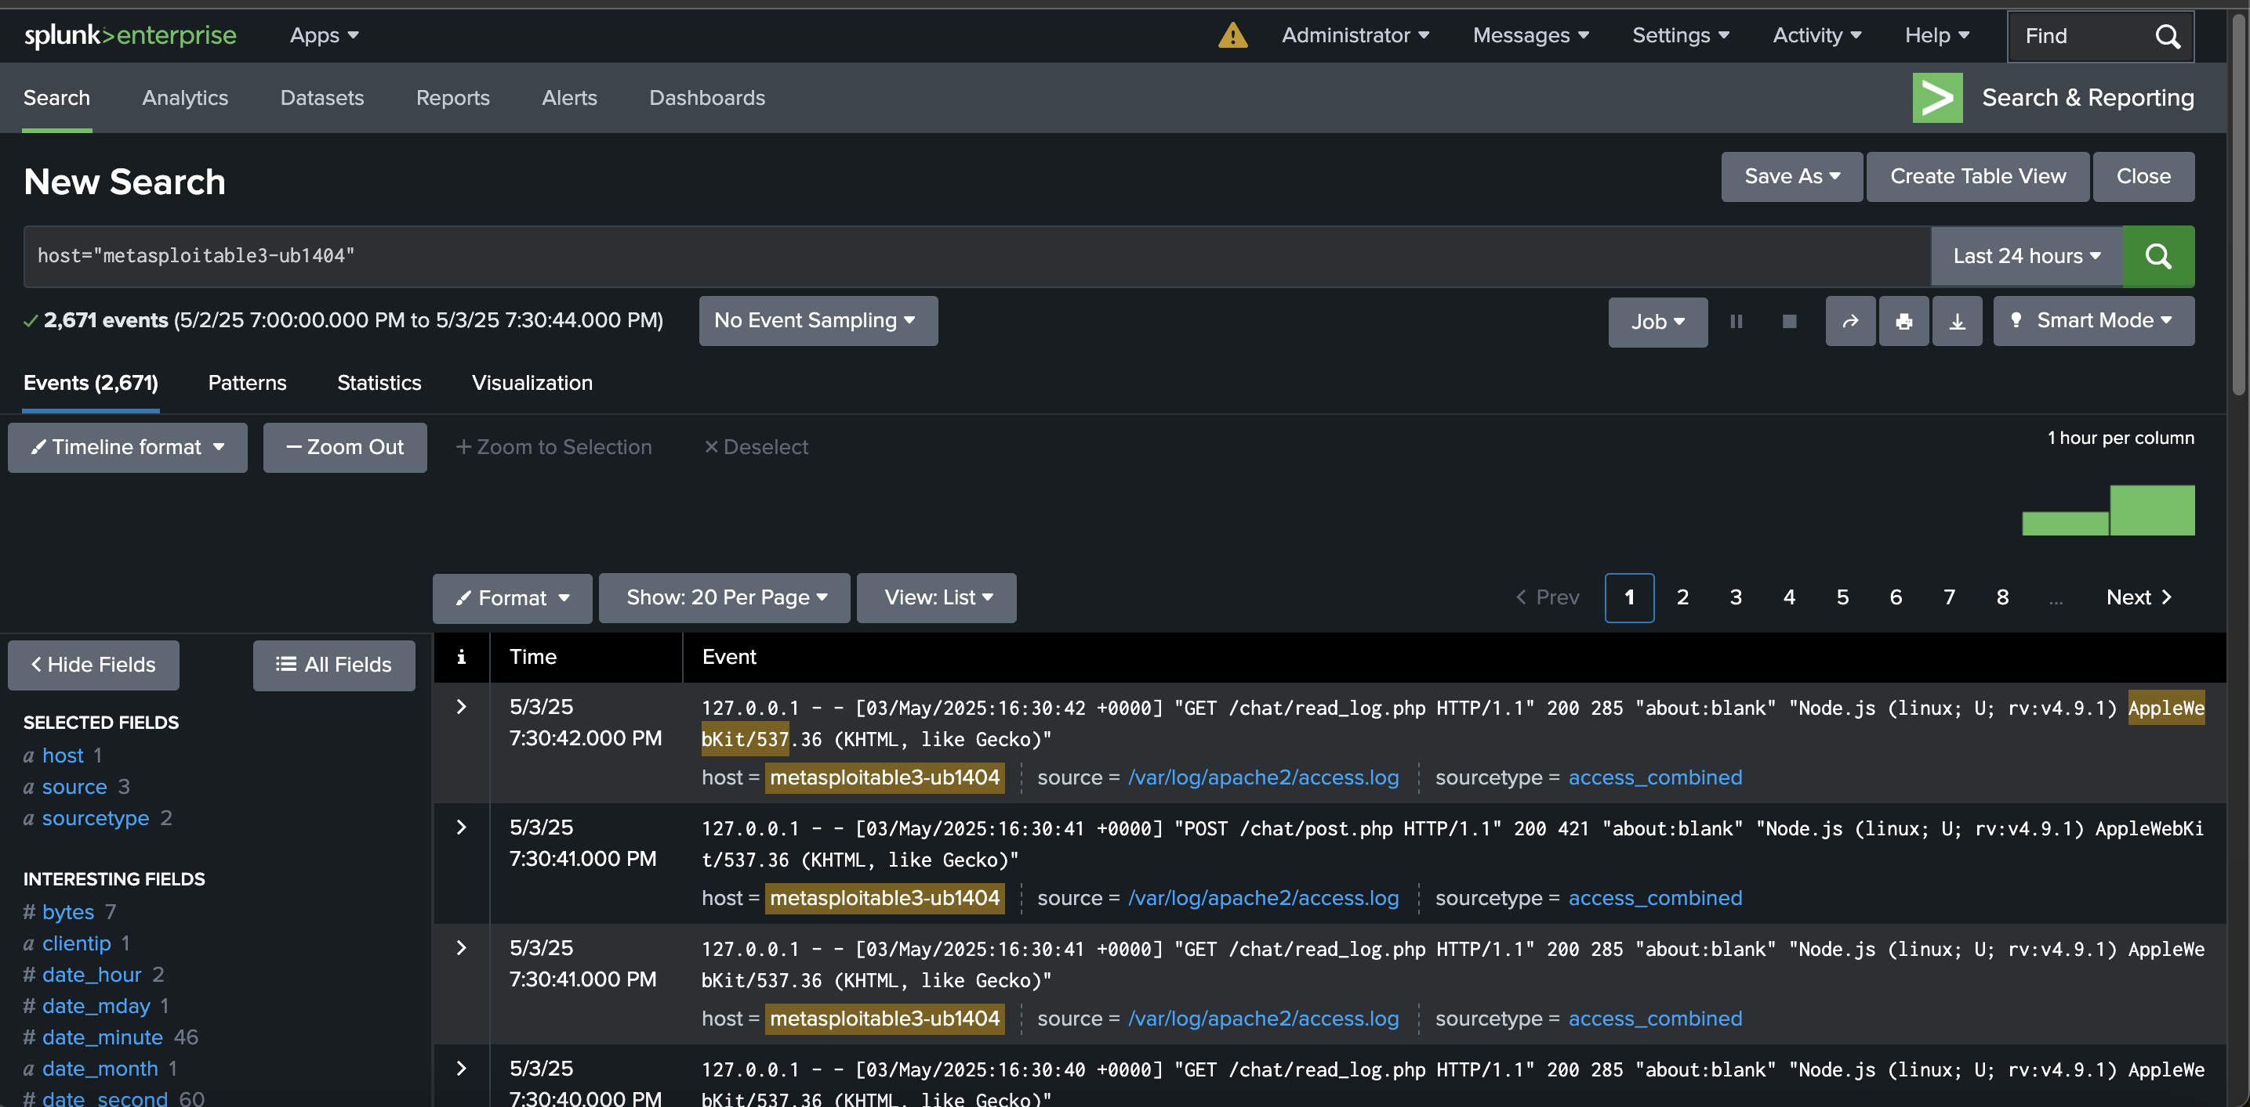

Step 6: Performing the same automated attack in step 2, phase I, and capturing the logs using Splunk in real time
